Introduction:
Assignment requires using IDLE to create and test a program.

Instructions:
For this assignment you will create a program that does some basic math on numbers that are entered. The instructions below explain the program requirements:

1. Create a Python code file that does the following
2. Add a title comment block to the top of the new Python file using the following form:
- # Your Name
- # Date
- # Assignment Name
- # A brief description of the project

3. Ask user to enter their budget
4. Ask user to enter travel destination
5. Ask user for amount they will spend on gas
6. Ask user for amount they will spend on accommodation
7. Ask user for amount they will spend on food
8. Add expenses
9. Subtract expenses from budget
10. Display results

Example output below. Note that the text in black is not part of the code. It represents the values that the user has entered once the program is running. These values should be able to change each time the program runs.
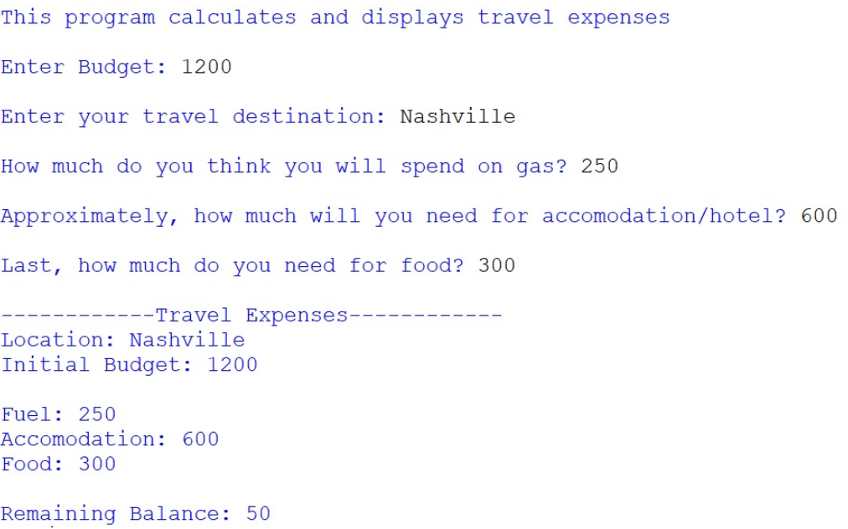

11. Submit your finished code through the P1HW2 assignment link by the posted deadline
Important Notes:

- Write program Pseudocode (logic) and add it as a comment block to the submitted program. (10 points)

